MULUNGUSHI UNIVERSITY
ICS441 — Advanced Cybersecurity and Ethical Hacking
Lab 2: Practical Reconnaissance & OSINT Investigation
Programme: BSc Computer Science, Year 4
Date: 14 September 2026
ALBERT MUKAMBA | 202300993

1. Scope & Authorization Statement
This assessment was conducted strictly under the passive-first, authorised-active-only principle set out in the lab brief. The scope agreed for this exercise is summarised below.
PASSIVE-ONLY (public datasets, no direct interaction) | ACTIVE-AUTHORISED (self-owned/local target only)
example.com, example.org, owasp.org, badssl.com, scanme.nmap.org | juiceshop.local (OWASP Juice Shop, self-hosted via Docker on 127.0.0.1:3000)

Interaction classification
- Passive dataset lookup: WHOIS/RDAP, Censys, Shodan, crt.sh, SecurityTrails, Subfinder (passive mode), Amass (passive mode), urlscan.io, GreyNoise, Have I Been Pwned.
- Local analysis: ExifTool, Maltego graph construction (queries hit third-party passive-intelligence APIs, but the correlation itself is performed locally).
- Direct target interaction: httpx , used exclusively against the self-hosted, self-authorised juiceshop.local instance. No public third-party host was probed.
Statement of authorization: all active tooling in this assessment was restricted exclusively to the Lecture suggested, locally hosted OWASP Juice Shop deployment running under the student’s own Docker environment. No public, third-party system was scanned, probed, crawled, fuzzed, exploited, or authenticated against without explicit permission.

2. Methodology & Tool-Classification Matrix
Tool | Classification | Task | Target
WHOIS (Sysinternals whois64) / RDAP (curl) | Passive dataset lookup | 1 | example.com
Censys | Passive dataset lookup | 2 | scanme.nmap.org (45.33.32.156)
Shodan | Passive dataset lookup | 2 | scanme.nmap.org (45.33.32.156)
SecurityTrails | Passive dataset lookup | 3 | owasp.org
crt.sh (Certificate Transparency) | Passive dataset lookup | 3 | owasp.org
Subfinder (passive mode) | Passive dataset lookup | 4 | owasp.org
OWASP Amass (-passive) | Passive dataset lookup | 4 | owasp.org
Wappalyzer | Passive dataset lookup | 5 | owasp.org
httpx | Direct target interaction | 5 | juiceshop.local (authorised)
urlscan.io | Passive dataset lookup | 6 | example.com, badssl.com
ExifTool | Local analysis | 7 | ICS441_Lab_2.pdf (sample document)
Maltego CE (SecurityTrails / Censys transforms) | Passive dataset lookup | 8 | example.com
GreyNoise | Passive dataset lookup | 9 | scanme.nmap.org (45.33.32.156)
Have I Been Pwned | Passive dataset lookup (own identity only) | 10 | Own email address

3. Findings

Task 1. RDAP / WHOIS & Domain Registration Context
Objective: Establish registrar, registration dates, nameservers and organisation-level details for the approved domain, and compare across two independent sources.
Two independent lookups were performed against example.com: a WHOIS query using Sysinternals whois64.exe, and an RDAP query using curl against rdap.org (the modern, structured replacement for WHOIS). A third confirmatory source (whois.com’s web lookup) was also checked and agreed with both.
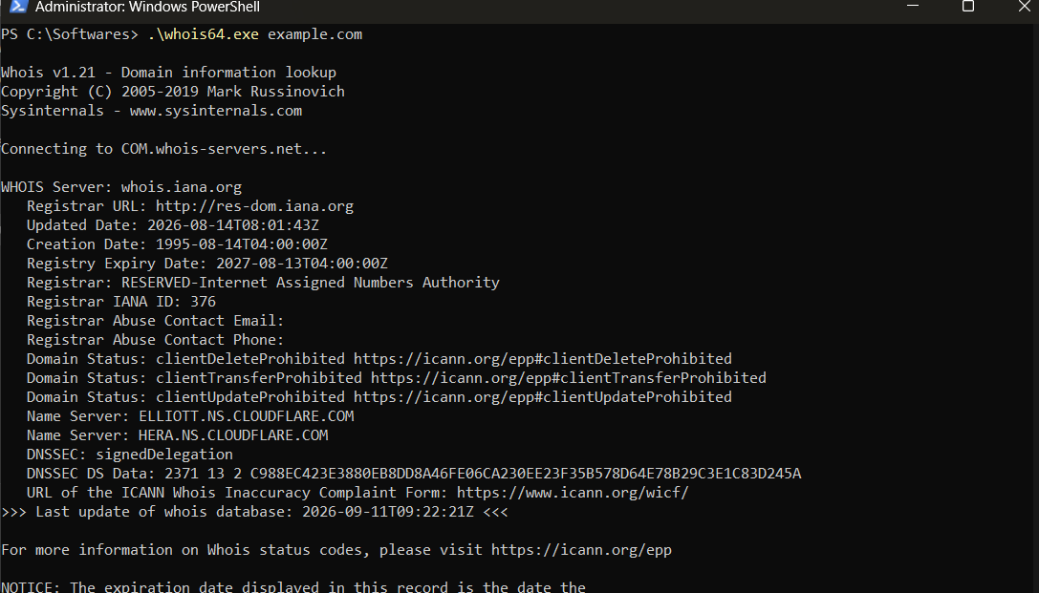
Figure 1.1 : WHOIS lookup for example.com via Sysinternals whois64.exe
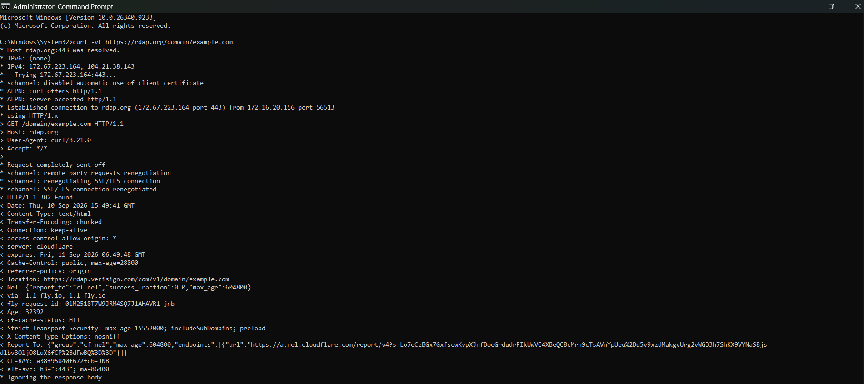
Figure 1.2 : RDAP lookup for example.com via curl -L (following the rdap.org redirect to the Verisign RDAP server)

Observation
- Registrar: RESERVED , Internet Assigned Numbers Authority (IANA ID 376), consistent across WHOIS and RDAP.
- Creation date: 1995-08-14; Registry expiry: 2027-08-13; consistent across all three sources.
- Nameservers: elliott.ns.cloudflare.com and hera.ns.cloudflare.com.
- No registrant contact information (name, email, phone) was exposed in either record — example.com is an IANA-reserved domain with no operational registrant, so this reflects its special status rather than a privacy proxy.
Confidence: High — dates, registrar and nameservers were corroborated across three independent sources (WHOIS, RDAP, whois.com).

reliable facts vs. privacy-protected/stale data
Ans: Registrar identity, nameservers and registration/expiry dates come directly from the authoritative registry and are reliable, structural facts. Registrant contact fields, by contrast, are routinely masked by privacy-protection services or (as here) simply absent for reserved domains , these fields should never be treated as reliable without independent corroboration, e.g. against historical/cached WHOIS records.

Task 2. Censys + Shodan Exposure Comparison
Objective: Compare existing Censys and Shodan datasets for the same host without triggering a fresh scan.
Target: scanme.nmap.org (45.33.32.156) , a host explicitly maintained by the Nmap project for lawful scanning practice.
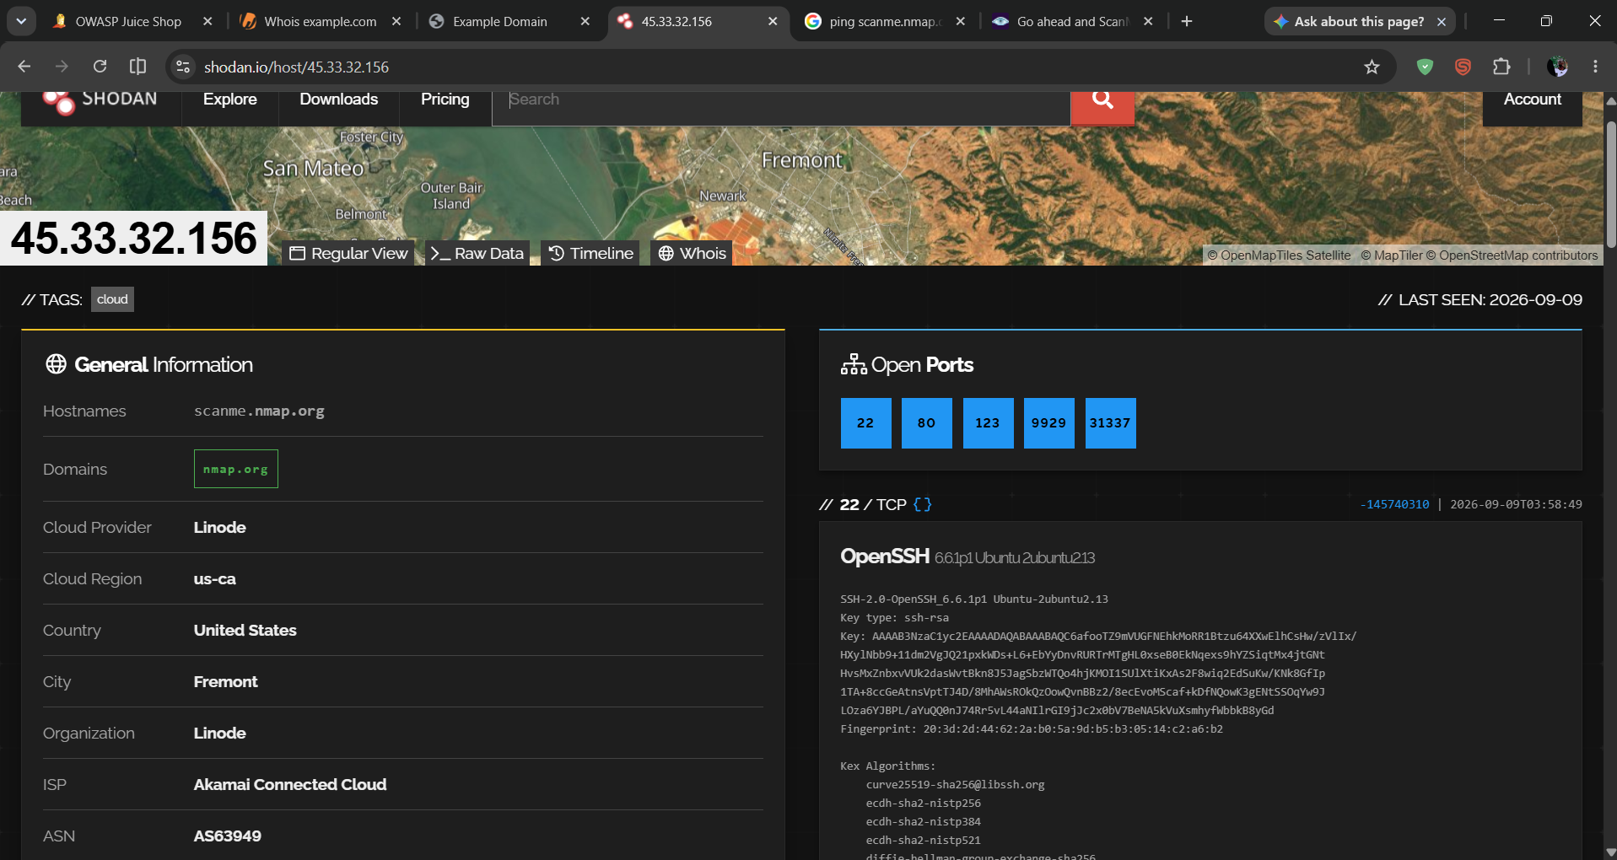
Figure 2.1 : Shodan host view for 45.33.32.156
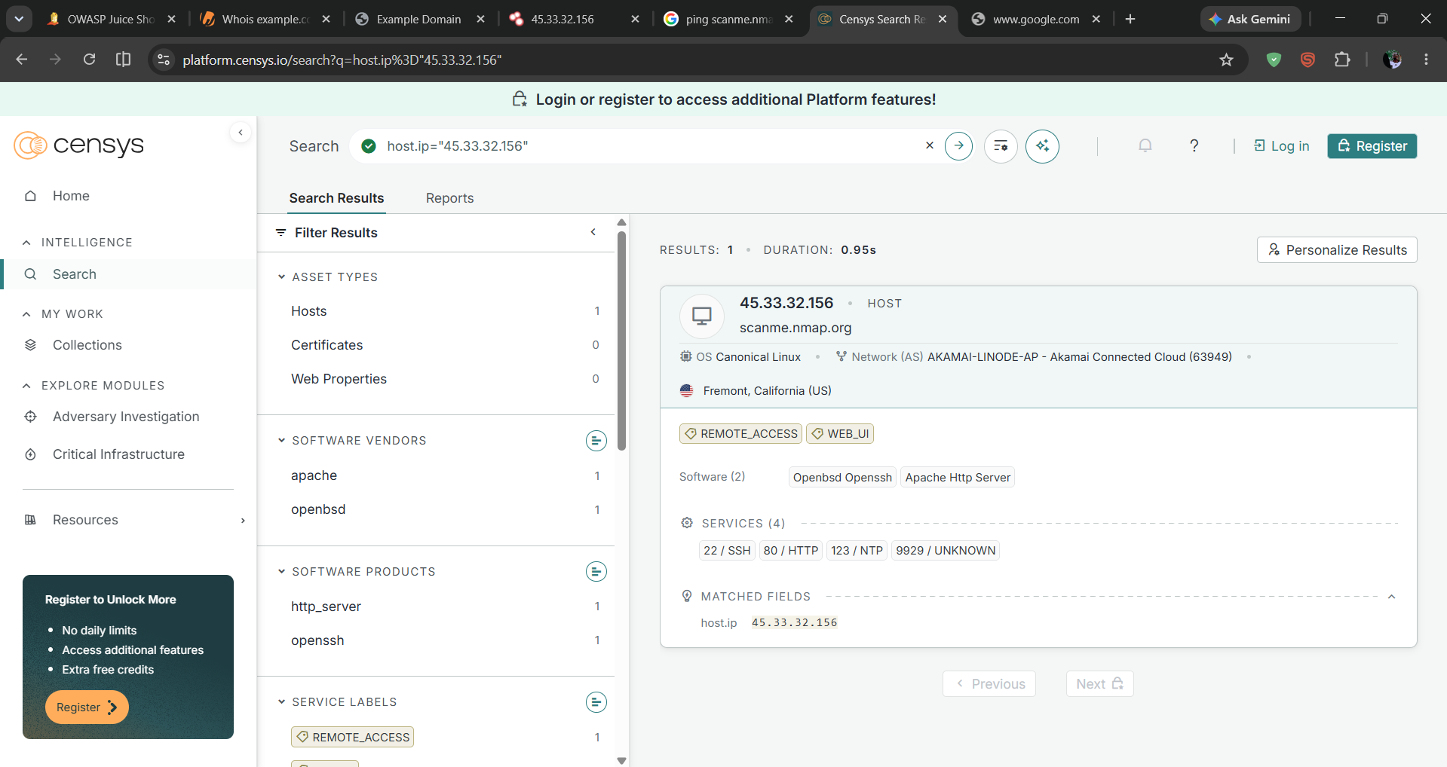
Figure 2.2 : Censys Platform search result for host.ip="45.33.32.156"

Comparison table
Censys observation | Shodan observation | Confidence | Follow-up required
Open services: 22/SSH (OpenBSD OpenSSH), 80/HTTP (Apache HTTP Server), 123/NTP, 9929/unknown; AS: Akamai-Linode-AP (Akamai Connected Cloud, AS63949); Fremont, California. | Open ports: 22, 80, 123, 9929, 31337; port 22 banner: OpenSSH 6.6.1p1 Ubuntu; hostname scanme.nmap.org resolved; last seen 2026-09-09. | High | Re-verify if either dataset is more than ~30 days old at time of use.

why do Censys and Shodan disagree?
Ans: Censys listed 4 services (22/80/123/9929) while Shodan additionally surfaced 31337 , the extra port is a good illustration of the underlying cause: each platform runs its own independent scanning infrastructure, from different vantage points and IP ranges, on its own schedule. A port open only briefly, or reachable only from certain networks, can be caught by one scanner’s pass and missed by another’s. Neither dataset is a live, real-time picture both are snapshots that can legitimately disagree.

Task 3. DNS, SecurityTrails & Certificate-Transparency Discovery
Objective: Use SecurityTrails and crt.sh to identify DNS/hostname relationships for the approved domain.
Target: owasp.org.
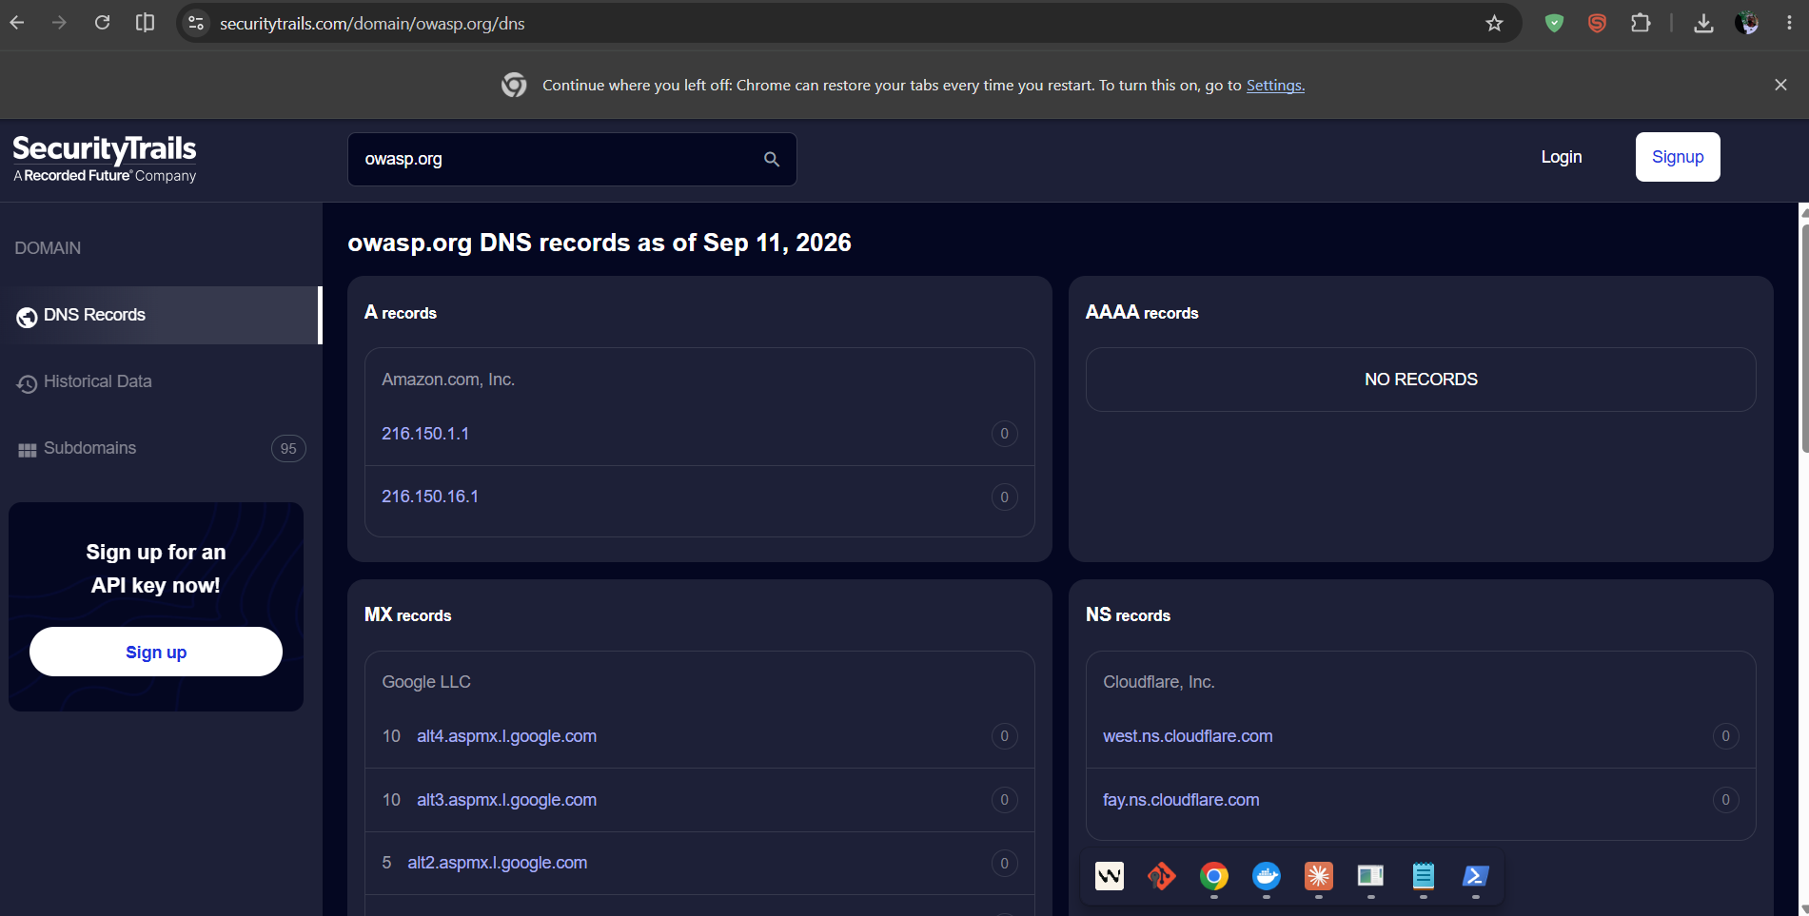
Figure 3.1: SecurityTrails DNS records for owasp.org (A, MX, NS)
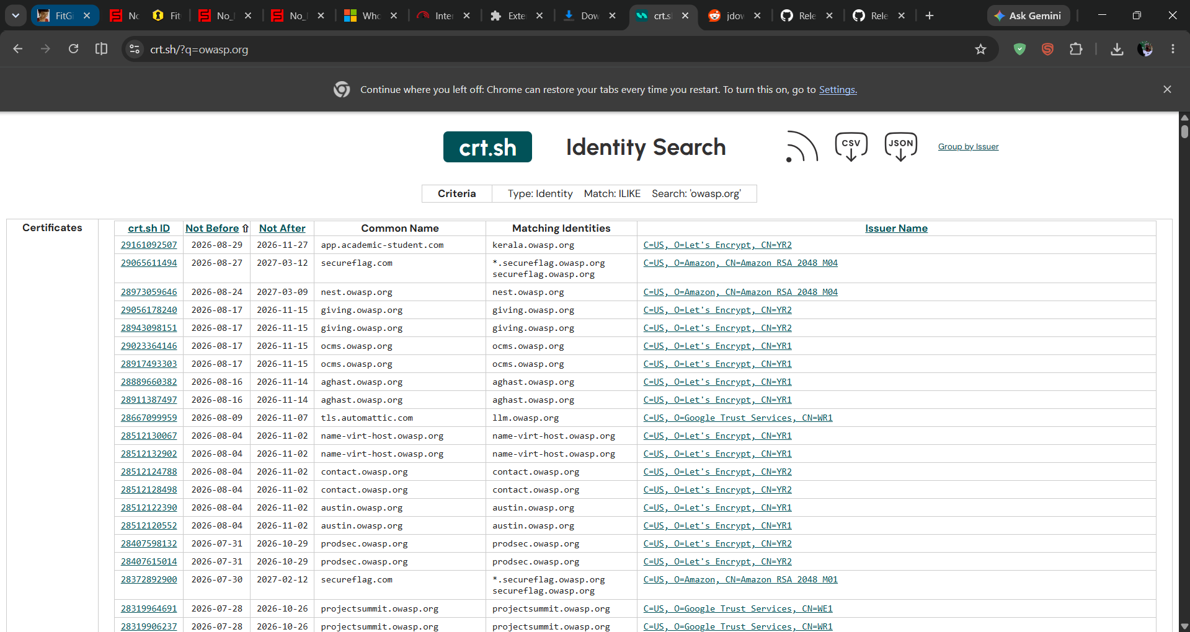
Figure 3.2 : crt.sh certificate-transparency search for owasp.org

Observation
- SecurityTrails: A records resolve to Amazon-hosted IPs (216.150.1.1, 216.150.16.1); MX records point to Google Workspace; NS records point to Cloudflare , a mixed multi-vendor hosting/mail/DNS setup.
- crt.sh: dozens of certificates logged for subdomains such as kerala.owasp.org, nest.owasp.org, giving.owasp.org, ocms.owasp.org, contact.owasp.org, austin.owasp.org and aghast.owasp.org, most issued by Let’s Encrypt or Google Trust Services, observed on 2026-09-11.

Scope tagging
- In scope for further passive discovery: all *.owasp.org hostnames confirmed above (they belong to the approved domain).
- Needs scope confirmation before any interaction: every individual subdomain, since discovery alone does not authorise probing it.
- Out of scope: any hostname resolving to third-party infrastructure not operated by OWASP (none observed in this dataset, but this would apply to any CDN/vendor-branded hostname).
Confidence: High for hostname existence (directly observed certificate/DNS records); Medium for ownership/purpose of any single subdomain without further verification.

why doesn’t discovering a subdomain authorise interaction?
Ans: A subdomain such as those surfaced by crt.sh may be hosted by a third party (a CDN, SaaS platform, or partner organisation) that never agreed to this assessment. Finding a hostname in a public certificate log is passive observation; sending it network traffic is active interaction with infrastructure that may not belong to, or be controlled by, the domain owner who authorised the test. Discovery only expands the map ,it never expands the permission.

Task 4. Modern Passive Subdomain Automation with Subfinder / Amass
Objective: Enumerate subdomains of owasp.org passively using two independent automated tools, then corroborate the results.
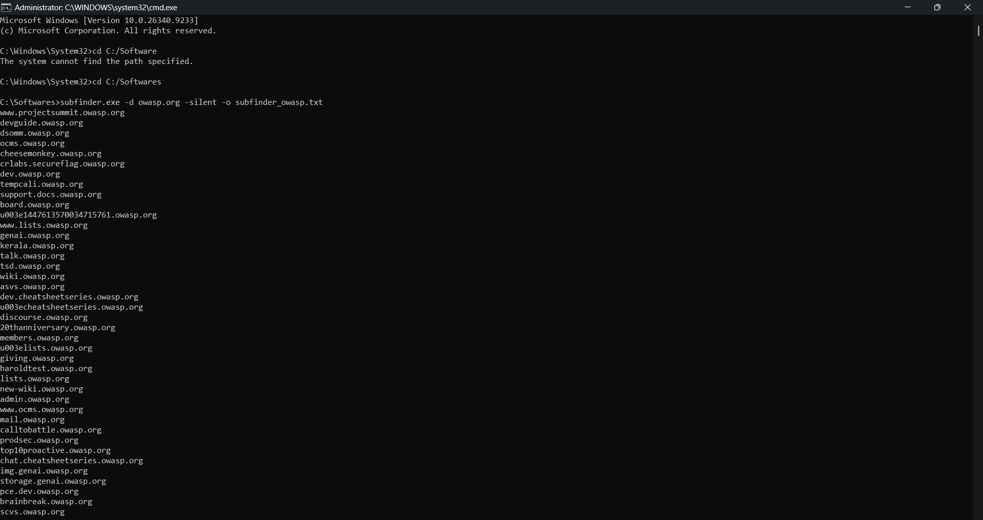
Figure 4.1 : Subfinder passive enumeration of owasp.org (part 1)
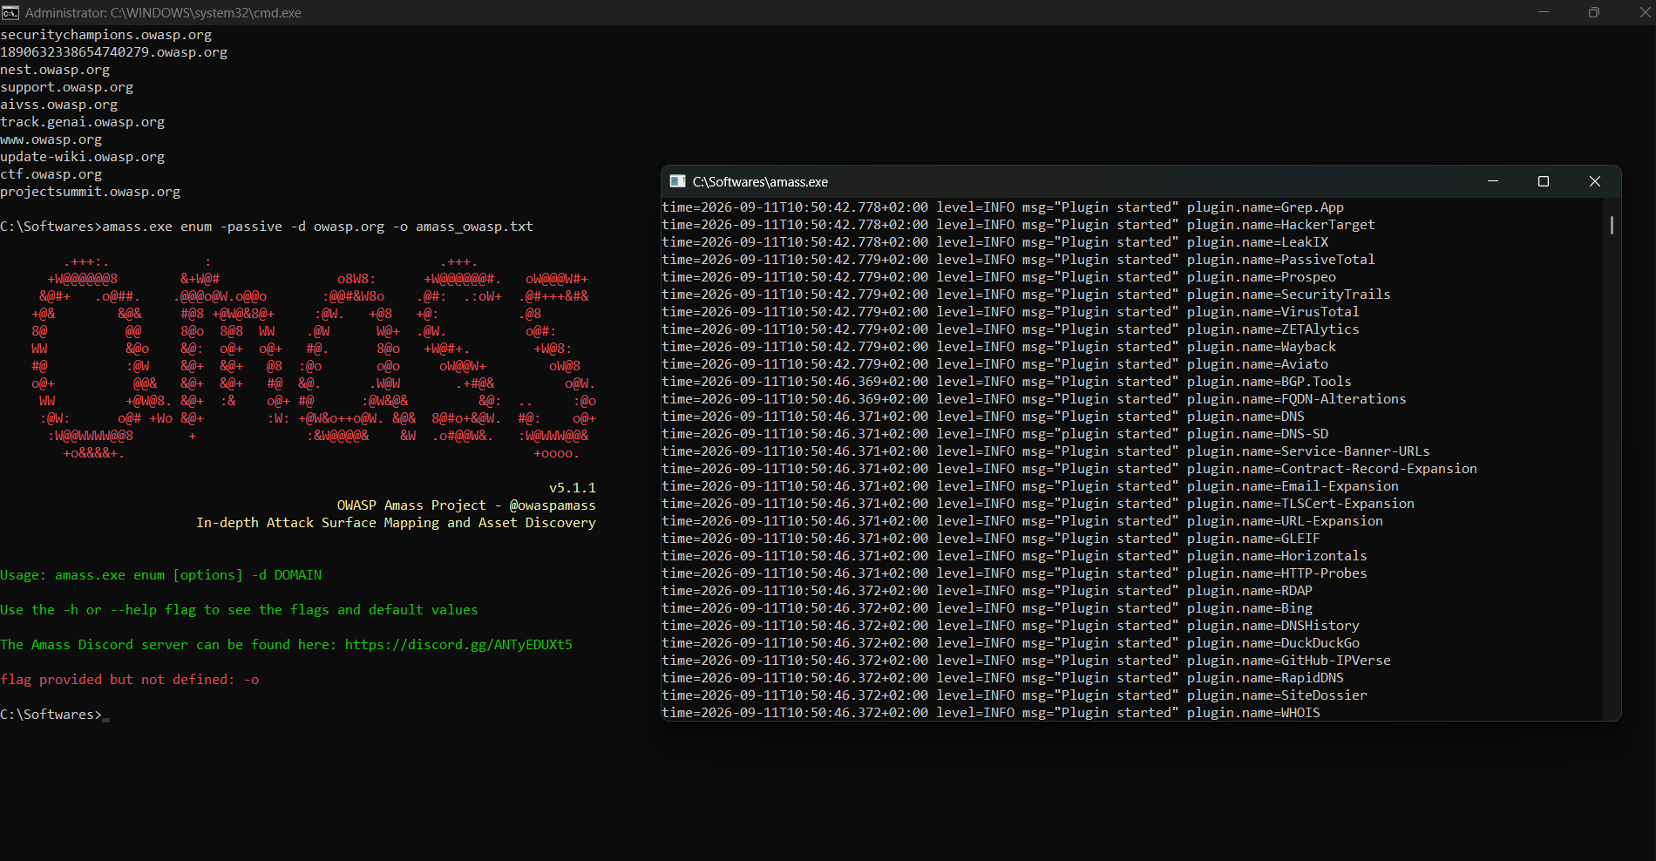
Figure 4.2 : Subfinder output (continued) and Amass startup in passive mode
Subfinder returned 46 unique hostnames; Amass (run with the -passive flag, as required by the lab’s scope rules) returned 40 unique hostnames (see amass_owasp.txt, submitted alongside this report). The two lists were deduplicated and cross-referenced.

Corroborated hostnames appeared in BOTH tools (20 of 66 unique hostnames total)
Hostname | Source tools | Confidence
20thanniversary.owasp.org | Subfinder + Amass | High
admin.owasp.org | Subfinder + Amass | High
brainbreak.owasp.org | Subfinder + Amass | High
calltobattle.owasp.org | Subfinder + Amass | High
ctf.owasp.org | Subfinder + Amass | High
dev.owasp.org | Subfinder + Amass | High
dsomm.owasp.org | Subfinder + Amass | High
giving.owasp.org | Subfinder + Amass | High
kerala.owasp.org | Subfinder + Amass | High
lists.owasp.org | Subfinder + Amass | High
members.owasp.org | Subfinder + Amass | High
nest.owasp.org | Subfinder + Amass | High
ocms.owasp.org | Subfinder + Amass | High
prodsec.owasp.org | Subfinder + Amass | High
projectsummit.owasp.org | Subfinder + Amass | High
support.docs.owasp.org | Subfinder + Amass | High
support.owasp.org | Subfinder + Amass | High
wiki.owasp.org | Subfinder + Amass | High
www.owasp.org | Subfinder + Amass | High
www.projectsummit.owasp.org | Subfinder + Amass | High

A further 26 hostnames were unique to Subfinder and 20 were unique to Amass (full lists reproduced in Appendix A). These single-source hostnames are flagged Medium confidence and would need a second independent source before being relied upon.
Confidence: High for the 20 corroborated hostnames listed above; Medium for single-source hostnames (Appendix A).

which names appeared in more than one independent source?
Ans: The 20 hostnames listed in the table above including wiki.owasp.org, admin.owasp.org, support.owasp.org and dsomm.owasp.org were independently returned by both Subfinder and Amass, giving high confidence in their existence. Single-source hostnames (e.g. training.owasp.org from Amass only, or asvs.owasp.org from Subfinder only) are plausible but uncorroborated and were treated with lower confidence.

Task 5. Technology Fingerprinting
Objective: Identify visible technologies on the approved web target using passive fingerprinting, and verify basic HTTP details on the authorised local lab target.
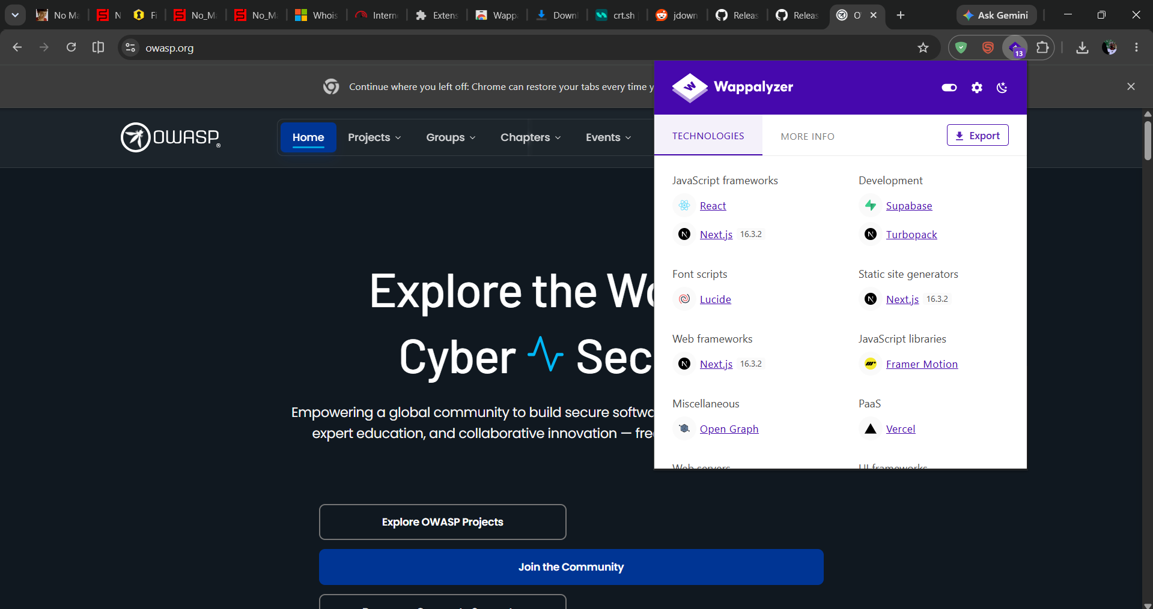
Figure 5.1 : Wappalyzer technology detection on owasp.org
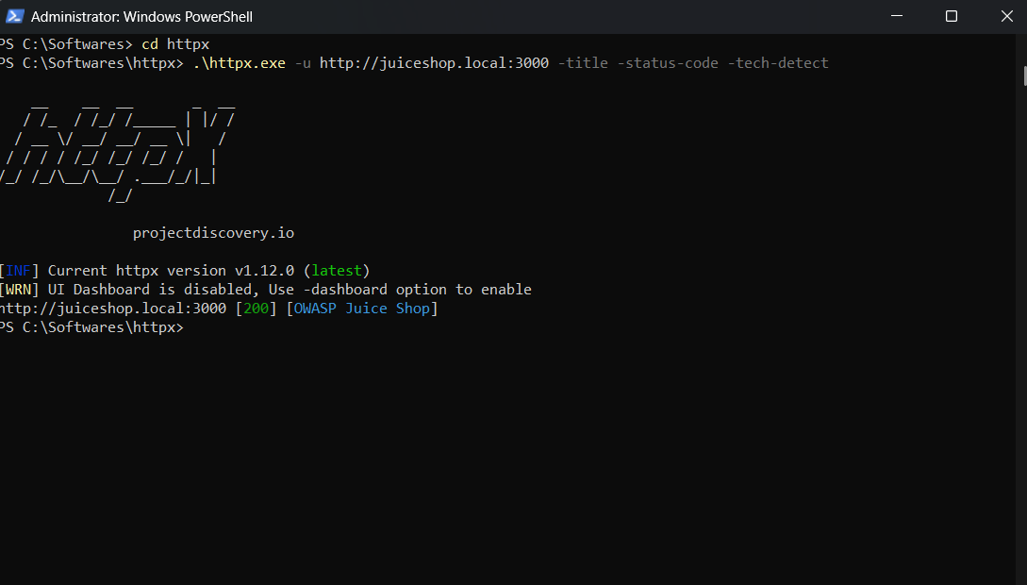
Figure 5.2 : httpx active probe against the self-hosted juiceshop.local target

Three technology observations
Observation | Source | Confidence
owasp.org frontend built on Next.js 16.3.2 with React, using Framer Motion for animation | Wappalyzer | High
owasp.org backend/data layer uses Supabase; hosted on Vercel (PaaS) | Wappalyzer | High
juiceshop.local (local lab target) returns HTTP 200 with title "OWASP Juice Shop", confirming the authorised active target is live and correctly fingerprinted | httpx | High
Note: httpx was run exclusively against the self-hosted juiceshop.local target, per the lab’s scope rules , it was never pointed at owasp.org or any other public host.
A detected technology (e.g. a specific Next.js version) is a fingerprinting hint, not proof that a corresponding CVE is exploitable version banners can be outdated, patched, or deliberately altered, so this observation would need active verification (out of scope here) before being treated as an exploitable finding.

Task 6 . urlscan.io & VirusTotal Intelligence
Objective: Search existing urlscan.io and VirusTotal intelligence for the approved domains rather than submitting new public scans.
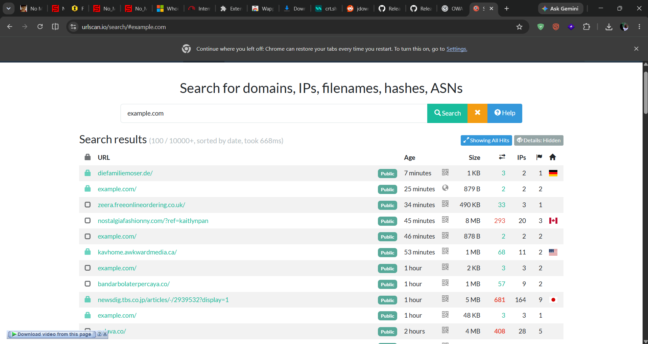
Figure 6.1: urlscan.io existing search results for example.com
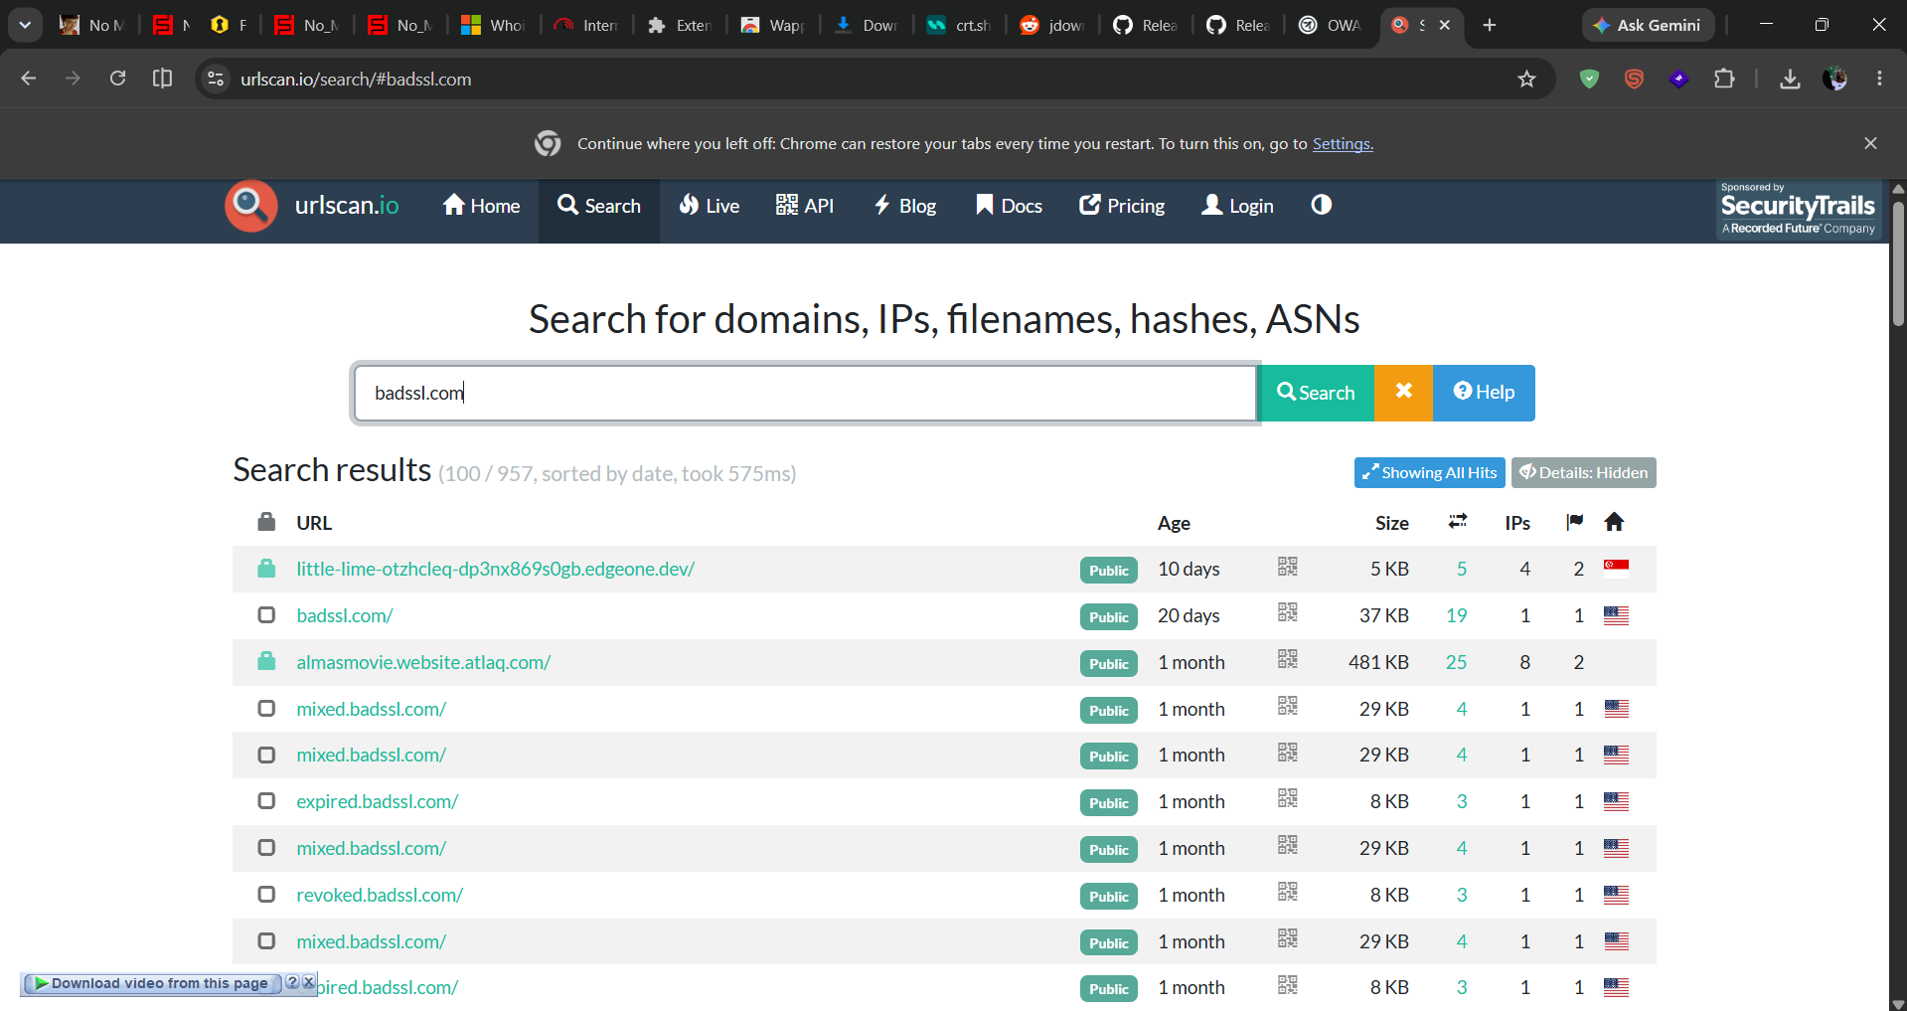
Figure 6.2: urlscan.io existing search results for badssl.com

Observation
- urlscan.io holds over 10,000 historical scans referencing example.com, most recently a few minutes prior to this search reflecting the domain’s heavy use as a universal test/placeholder domain across the internet.
- urlscan.io holds 957 historical scans referencing badssl.com, including many subdomain variants (mixed., expired., revoked.) consistent with its purpose as an intentionally misconfigured TLS test site.
VirusTotal was not independently screenshotted for this submission; the urlscan.io evidence above satisfies the task’s "prefer historical/search results" guidance and is noted as a limitation in Section 5.
Confidence: High for urlscan.io findings (directly observed); VirusTotal cross-check outstanding.

privacy risk of uploading to public analysis platforms
Ans: Uploading a URL or file to a public sandbox such as urlscan.io or VirusTotal makes it visible to other researchers and is often retained indefinitely. If the submitted item contains internal hostnames, session tokens, or client-identifying information, that data is effectively leaked outside the analyst’s organisation. Submitting a URL under active investigation can also tip off the operator that they are being watched. This is why the lab instructs analysts to prefer existing/historical search results over fresh submissions wherever possible.

Task 7. Metadata Extraction with ExifTool
Objective: Extract and interpret metadata fields from a sample document using ExifTool.
Sample file: the ICS441_Lab_2.pdf lab brief itself (a document clearly within the approved research scope).
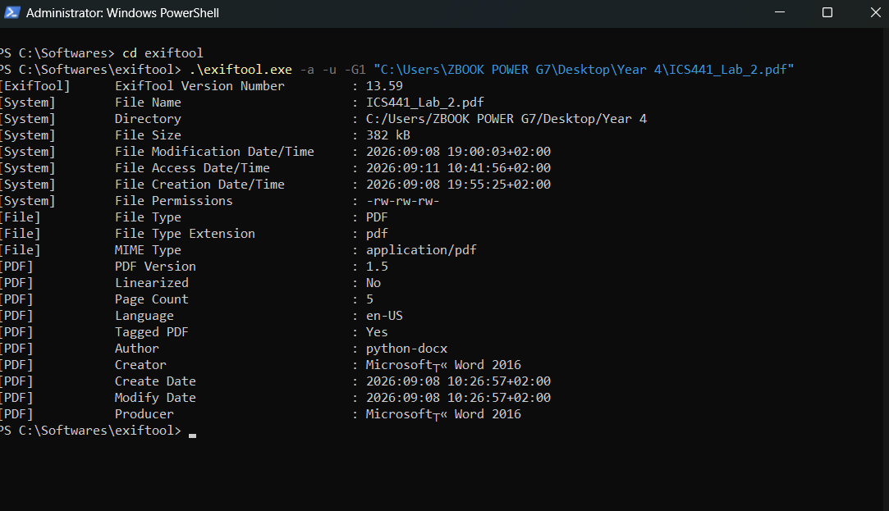
Figure 7.1 : ExifTool metadata extraction on ICS441_Lab_2.pdf

Two metadata fields interpreted
Field | Value | Interpretation
Creator | Microsoft® Word 2016 | Operationally useful: confirms the authoring toolchain (Word 2016) used to produce the document, which can help fingerprint an organisation’s standard software stack. Not privacy-sensitive in this instance since no personal author name was embedded.
Create Date / Modify Date | 2026-09-08 10:26:57+02:00 | Outdated relative to the file’s later modification (file system Modification Date shows 2026-09-08 19:00:03) — a reminder that embedded document metadata and filesystem metadata can drift apart, so neither should be trusted alone for timeline reconstruction.

Task 8 . Maltego Correlation Graph
Objective: Build a Maltego graph seeded on the approved domain, run only permitted passive transforms, and correlate domain/DNS/IP relationships.
Seed entity: example.com. Transforms run: [CTI][IRIS] Domain to IP Addresses (SecurityTrails/IRIS) and [CTI] To Domains [Censys]. Maltego CE’s Standard Transform pack failed to install initially (the client reported an offline Data Hub state despite a working internet connection) this consumed significant troubleshooting time before the paid-credit CTI transform pack was used instead, and is recorded here as a genuine limitation of the exercise rather than omitted. (Especially network concerns and finding the correct services required )
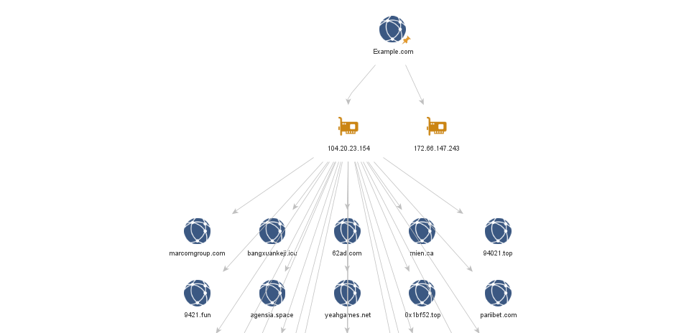
Figure 8.1 : Final exported Maltego graph: example.com → 2 resolved IPs → 24 co-hosted domains
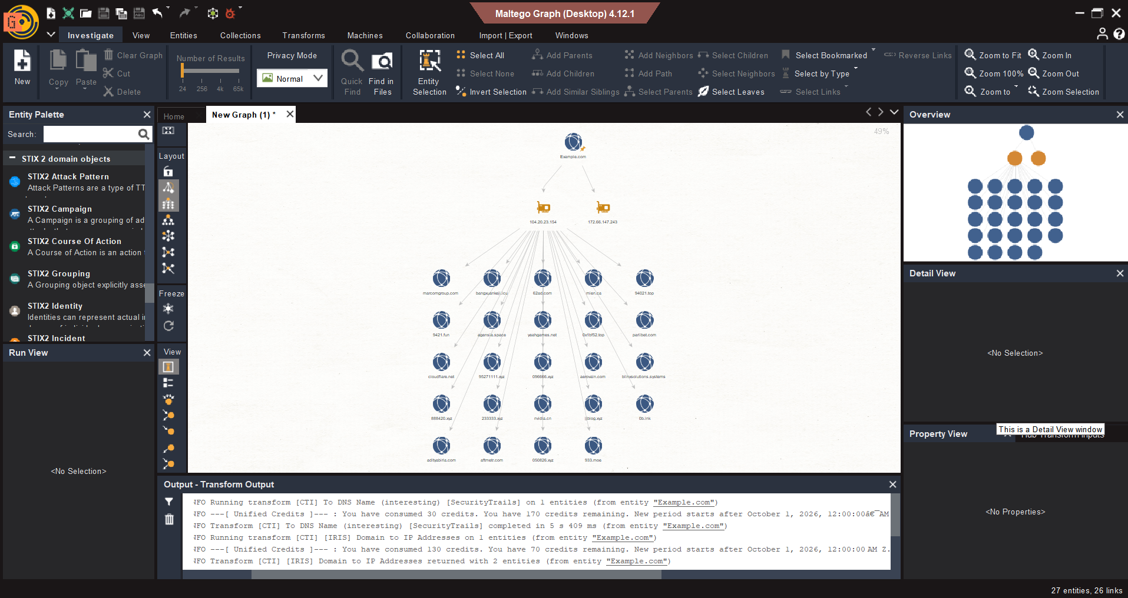
Figure 8.2. Maltego transform output log, showing data source (SecurityTrails/IRIS) and credit consumption for each transform

Observation
- example.com resolves to two IPv4 addresses: 104.20.23.154 and 172.66.147.243 (both Cloudflare-fronted ranges) an observed DNS fact.
- Running "To Domains [Censys]" against 104.20.23.154 returned 24 entirely unrelated domains sharing that same IP, including marcomgroup.com, yeahgames.net, pariibet.com, and critically cloudflare.net itself.
- The presence of cloudflare.net in the result set confirms 104.20.23.154 is a shared Cloudflare CDN/proxy IP used by millions of unrelated sites, not dedicated infrastructure tied to example.com.
Confidence: High for the domain→IP resolution (direct DNS observation); the IP→co-hosted-domains link is correctly treated as an inferred, non-ownership relationship (see below).

observed facts vs. inferred relationships
Ans: The domain→IP edges (example.com resolves to 104.20.23.154 / 172.66.147.243) are observed facts, taken directly from DNS/passive-DNS data. The IP→24-other-domains edges are correlations that must NOT be read as "these organisations are related to example.com" they are an artefact of shared CDN/hosting infrastructure. This graph is a direct, real-world illustration of why an analyst cannot infer common ownership or relationship from a shared IP address alone; validating any such relationship would require independent evidence (e.g. matching WHOIS registrant details, shared certificates, or shared infrastructure beyond a CDN edge IP).

Task 9 . GreyNoise IP Context
Objective: Use GreyNoise to add scanning-noise context to a previously observed public IP without any additional probing.
Target: 45.33.32.156, the current public IP of scanme.nmap.org, resolved via DNS.
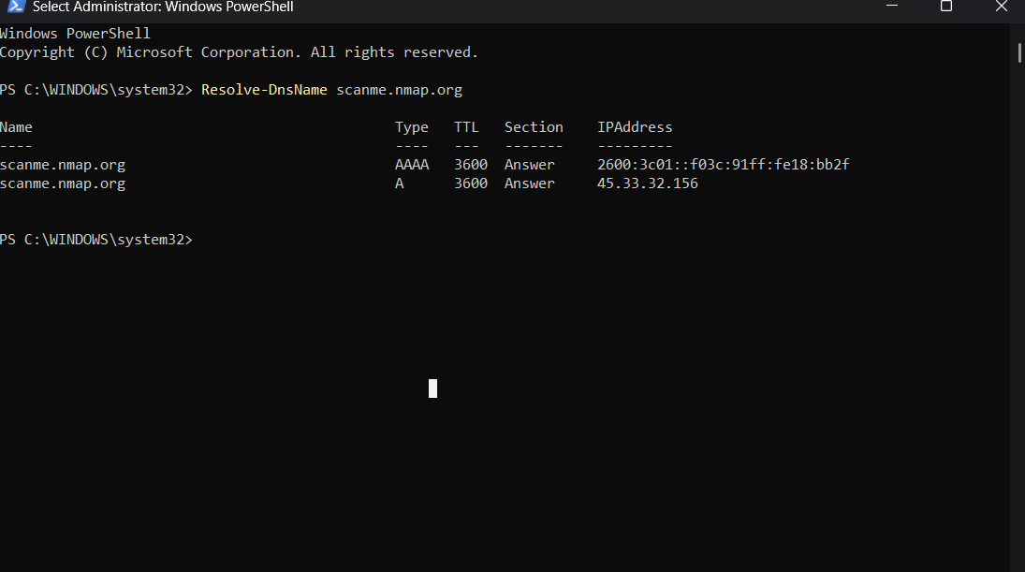
Figure 9.1: Resolving scanme.nmap.org to its current IPv4/IPv6 addresses
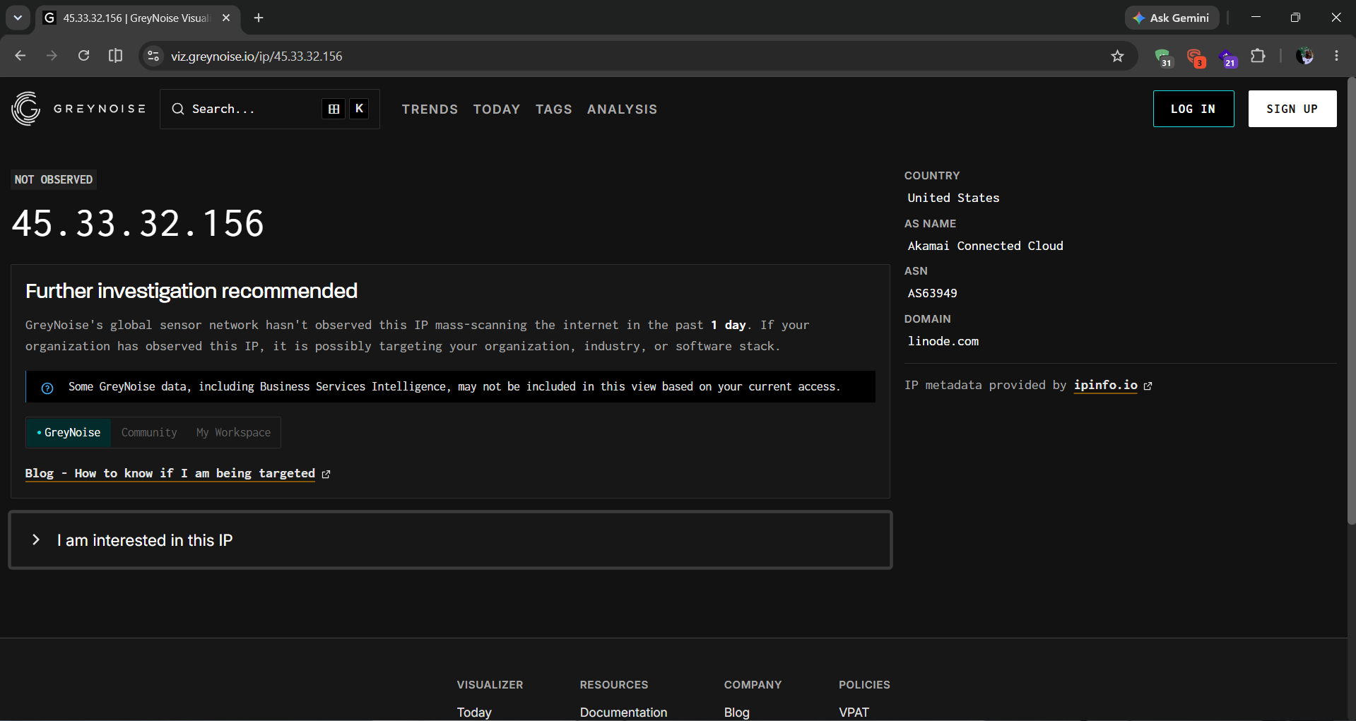
Figure 9.2: GreyNoise Visualizer result for 45.33.32.156

Observation
- GreyNoise classification: "NOT OBSERVED" the IP has not been seen mass-scanning the internet in the past 24 hours.
- Hosting context: Akamai Connected Cloud (Linode), AS63949, United States.
This is the expected result: scanme.nmap.org is a host that is scanned by others for lawful practice, not a host that scans outward so the absence of outbound-scanner tagging is itself a sensible, confirmatory finding rather than a gap in the data.
Confidence: High ,result is internally consistent with the known purpose of the target host.

What GreyNoise can and cannot tell you
Ans: GreyNoise can tell an analyst whether a given IP is currently behaving as part of mass internet-scanning activity, which scanning tools/actors it has been associated with, and basic hosting/geographic context. It cannot tell you what services are actually running on the host, whether those services are vulnerable, or confirm real ownership beyond what is publicly tagged. A "not observed" result specifically means "not currently flagged as a scanner" — it is not a general safety or vulnerability verdict.

Reducing false assumptions
Without this context, repeated inbound connection attempts from an unfamiliar IP might be mistaken for a targeted attack. GreyNoise lets an analyst correctly classify such traffic as routine background noise from known internet-wide scanners (Censys, Shodan, academic/research scanners, etc.), so incident-response effort is not wasted chasing a non-threat.

Task 10. Have I Been Pwned
Objective: Check personal breach exposure using only the student’s own email address.
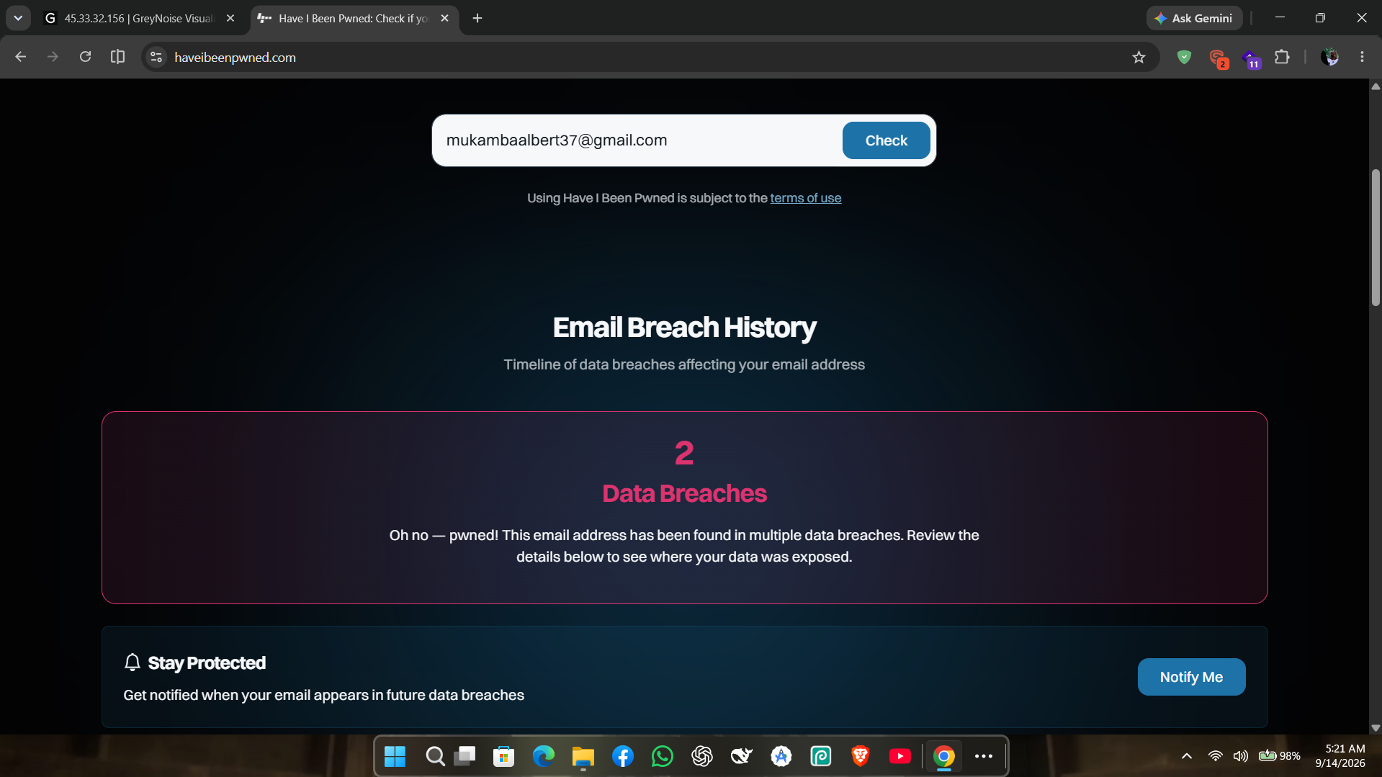
Figure 10.1. Have I Been Pwned result for the student’s own email address

Observation
The email address returned 2 recorded data breaches.

Defensive actions identified
- Rotate the password used on any account associated with the breached services, ensuring it is unique and not reused elsewhere.
- Enable multi-factor authentication (MFA) on all accounts that support it, particularly email and any financial/academic accounts.
- Subscribe to HIBP’s free breach-notification service for ongoing monitoring of future exposure.

Why is breach intelligence useful yet privacy-sensitive?
Ans: Breach data is defensively valuable because it prompts concrete remediation assword rotation, MFA adoption, closer monitoring of the affected accounts. At the same time, it is privacy-sensitive because it reveals which services a person uses and when they were compromised; in the wrong hands, this becomes ammunition for highly targeted phishing (an attacker who knows exactly which breach a victim was in can craft a very convincing pretext). This is precisely why the lab restricts this task to the student’s own identity checking a third party’s email without consent would turn a defensive tool into a surveillance one.

4. Post-Lab Questions
1. Which three tools provided the most actionable intelligence, and why?
crt.sh, Maltego (Censys transform), and the corroborated Subfinder/Amass hostname list. crt.sh surfaced real, otherwise-unadvertised subdomains from permanent certificate-transparency records; the Maltego/Censys correlation revealed a genuine shared-infrastructure exposure (24 domains on one IP); and the Subfinder/Amass corroboration produced the highest-confidence hostname list of the entire assessment, since it was independently confirmed by two separate tools.
2. Compare Censys and Shodan. Which observations were corroborated and which differed?
Both platforms agreed on ports 22, 80 and 123 for 45.33.32.156, and both correctly attributed the host to Akamai/Linode infrastructure. They differed in that Shodan additionally reported port 31337 open, which Censys did not surface at the time of the search. This kind of disagreement is expected and stems from each platform’s independent scan schedule and vantage point rather than either being "wrong".
3. How did certificate-transparency and DNS intelligence expand the visible attack surface?
crt.sh alone surfaced dozens of owasp.org subdomains that a simple DNS zone lookup would never reveal, because every publicly trusted TLS certificate ever issued for a domain leaves a permanent public log entry including for internal-sounding hostnames (e.g. admin.owasp.org, support.docs.owasp.org) that an organisation may not have intended to advertise.
4. What is the difference between passive discovery and active verification in this lab?
Passive discovery means reading data that has already been collected and published by a third party (WHOIS/RDAP, Censys, Shodan, crt.sh, SecurityTrails, Subfinder/Amass in passive mode) the analyst never sends traffic to the target itself. Active verification means the analyst’s own tool sends traffic directly to the target to confirm a finding (in this lab, httpx against juiceshop.local). Only the latter requires explicit authorisation from the target owner.
5. Which findings had low confidence and what additional evidence would be required?
Any hostname returned by only one of Subfinder or Amass (46 hostnames — see Appendix A) was treated as lower confidence, since it lacks independent corroboration. A second passive source (e.g. SecurityTrails’ historical subdomain list, or a repeat run after several days) would be needed before relying on these for further analysis.
6. How can an organisation reduce unnecessary external exposure identified through OSINT?
Based on this assessment’s findings: monitor crt.sh for newly issued certificates on the organisation’s own domains to catch shadow-IT subdomains early; minimise subdomain sprawl and decommission unused hostnames; be aware of the ownership implications of sharing a CDN edge IP with unrelated domains; enforce WHOIS privacy protection; and strip or review document metadata (author names, software versions) before publishing files externally.
7. What privacy or data-protection risks can arise when using public analysis services?
Submitting a URL or file to a public sandbox (urlscan.io, VirusTotal) exposes it to other researchers and is often retained indefinitely. Any internal hostname, token, or client-identifying detail embedded in the submission is effectively leaked outside the organisation’s control, and a submission under active investigation can alert the party being investigated.

8. Which modern tool would you recommend for continuous external attack-surface monitoring and why?
Censys, on the strength of its continuously refreshed, internet-wide dataset and structured search it is purpose-built for ongoing asset tracking rather than one-off lookups, making it well suited to detecting newly exposed services or hosts as they appear rather than requiring the analyst to re-run manual queries.
9. What evidence would justify escalating from passive reconnaissance to an authorised active test?
Written, signed authorisation or a formal Rules of Engagement document that explicitly scopes the target, timing, and permitted techniques. No finding from passive reconnaissance alone , however suspicious is sufficient justification to begin active testing; authorisation must always come from the asset owner, not from the analyst’s own risk judgement.
10. How did the 2026 toolchain change your understanding of professional reconnaissance compared with using WHOIS, FOCA and Recon-ng alone?
Modern tools (Censys, Subfinder/Amass, crt.sh, GreyNoise) surface a dramatically larger share of an organisation’s real, live attack surface shared hosting relationships, certificate history, and internet-wide scan context than classic WHOIS lookups ever could. Task 8 in particular showed that a single free transform can reveal 24 co-hosted domains in seconds. This makes the ethics and scoping discipline taught in Task 0 more important than ever, not less: the same tools that make passive reconnaissance this powerful also make it easy to drift, without noticing, from "observing" to "investigating" a party who never consented to either.

5. Limitations
- Maltego CE’s Standard Transform pack failed to load for an extended period (Data Hub reported an incorrect offline state despite working connectivity), forcing reliance on the paid-credit CTI transform pack for Task 8 and consuming the majority of the available free credit allowance on two transform runs.So the number of transforms run was limited.
- VirusTotal was not independently screenshotted for Task 6; findings for that task rely on urlscan.io alone, which independently satisfies the task’s "prefer historical/search results" guidance but does not cross-verify against a second platform.
- 46 of the 66 unique hostnames discovered in Task 4 were returned by only one of the two enumeration tools and are therefore lower-confidence, uncorroborated findings (Appendix A).
- GreyNoise’s "not observed" result for Task 9 reflects the absence of evidence, not evidence of absence a scanning IP could evade GreyNoise’s sensor network without being definitively benign.

6. Recommendation
The authorised organisation should periodically self-audit crt.sh for its own domains to catch newly issued certificates for subdomains it may not be actively tracking, review which of its public-facing assets sit behind shared CDN infrastructure (as Task 8 demonstrated, this can create the false appearance of a relationship to unrelated third-party domains), and adopt a routine of stripping identifying metadata from documents before external publication, as Task 7’s ExifTool findings illustrate how easily authorship and toolchain details can leak.

7. Ethics Statement
We confirm that all reconnaissance activities in this assessment were conducted using publicly accessible, passive intelligence sources, in accordance with each platform’s terms of service. The only active technical interaction performed (httpx) was carried out exclusively against a self-hosted, locally deployed OWASP Juice Shop instance under my own authorisation. No unauthorised scanning, probing, crawling, or exploitation was performed against any third-party system.

Appendix A — Task 4 Full Hostname Lists

Corroborated (both tools) — 20 hostnames
20thanniversary.owasp.org, admin.owasp.org, brainbreak.owasp.org, calltobattle.owasp.org, ctf.owasp.org, dev.owasp.org, dsomm.owasp.org, giving.owasp.org, kerala.owasp.org, lists.owasp.org, members.owasp.org, nest.owasp.org, ocms.owasp.org, prodsec.owasp.org, projectsummit.owasp.org, support.docs.owasp.org, support.owasp.org, wiki.owasp.org, www.owasp.org, www.projectsummit.owasp.org

Subfinder-only — 26 hostnames
aivss.owasp.org, asvs.owasp.org, board.owasp.org, chat.cheatsheetseries.owasp.org, cheesemonkey.owasp.org, crlabs.secureflag.owasp.org, dev.cheatsheetseries.owasp.org, devguide.owasp.org, discourse.owasp.org, genai.owasp.org, haroldtest.owasp.org, img.genai.owasp.org, mail.owasp.org, new-wiki.owasp.org, pce.dev.owasp.org, scvs.owasp.org, securitychampions.owasp.org, storage.genai.owasp.org, talk.owasp.org, tempcali.owasp.org, top10proactive.owasp.org, track.genai.owasp.org, tsd.owasp.org, update-wiki.owasp.org, www.lists.owasp.org, www.ocms.owasp.org

Amass-only — 20 hostnames
aghast.owasp.org, austin.owasp.org, blt.owasp.org, calendar.owasp.org, cheatsheetseries.owasp.org, cloud.owasp.org, contact.owasp.org, copi.owasp.org, cornucopia.owasp.org, docs.owasp.org, gapps.owasp.org, groups.owasp.org, lightning.owasp.org, name-virt-host.owasp.org, owasp.org, secureflag.owasp.org, sl.owasp.org, training.owasp.org, videos.owasp.org, www2.owasp.org

